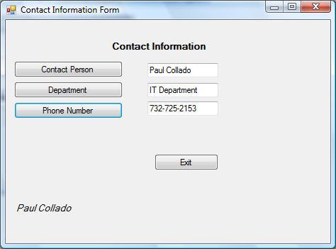
Public Class FrmColladoCh01Page57

Private Sub BtnContact_Click(ByVal sender As System.Object, ByVal e As System.EventArgs) Handles btnContact.Click
'Display contact person
Me.txtContact.Text = "Paul Collado"

End Sub

Private Sub TxtContact_TextChanged(ByVal sender As System.Object, ByVal e As System.EventArgs) Handles txtContact.TextChanged

End Sub

Private Sub btnDepartment_Click(ByVal sender As System.Object, ByVal e As System.EventArgs) Handles btnDepartment.Click
'Display Department
Me.txtDepartment.Text = "IT Department"

End Sub

Private Sub btnPhone_Click(ByVal sender As System.Object, ByVal e As System.EventArgs) Handles btnPhone.Click
'Display Phone Number
Me.txtPhone.Text = "732-725-2153"

End Sub

Private Sub Button2_Click(ByVal sender As System.Object, ByVal e As System.EventArgs) Handles Button2.Click
'Exits the program
Me.Close()

End Sub
End Class

